Section One:

The Inside Job – Building Your Foundation

(Complete Exercises)

SECTION 1, STAGE 1
Step 1: Completing the Flourishing questionnaire
Complete the following short questionnaire using a 1 to 5 scale (1 being “strongly disagree” and 5 being “strongly agree”):

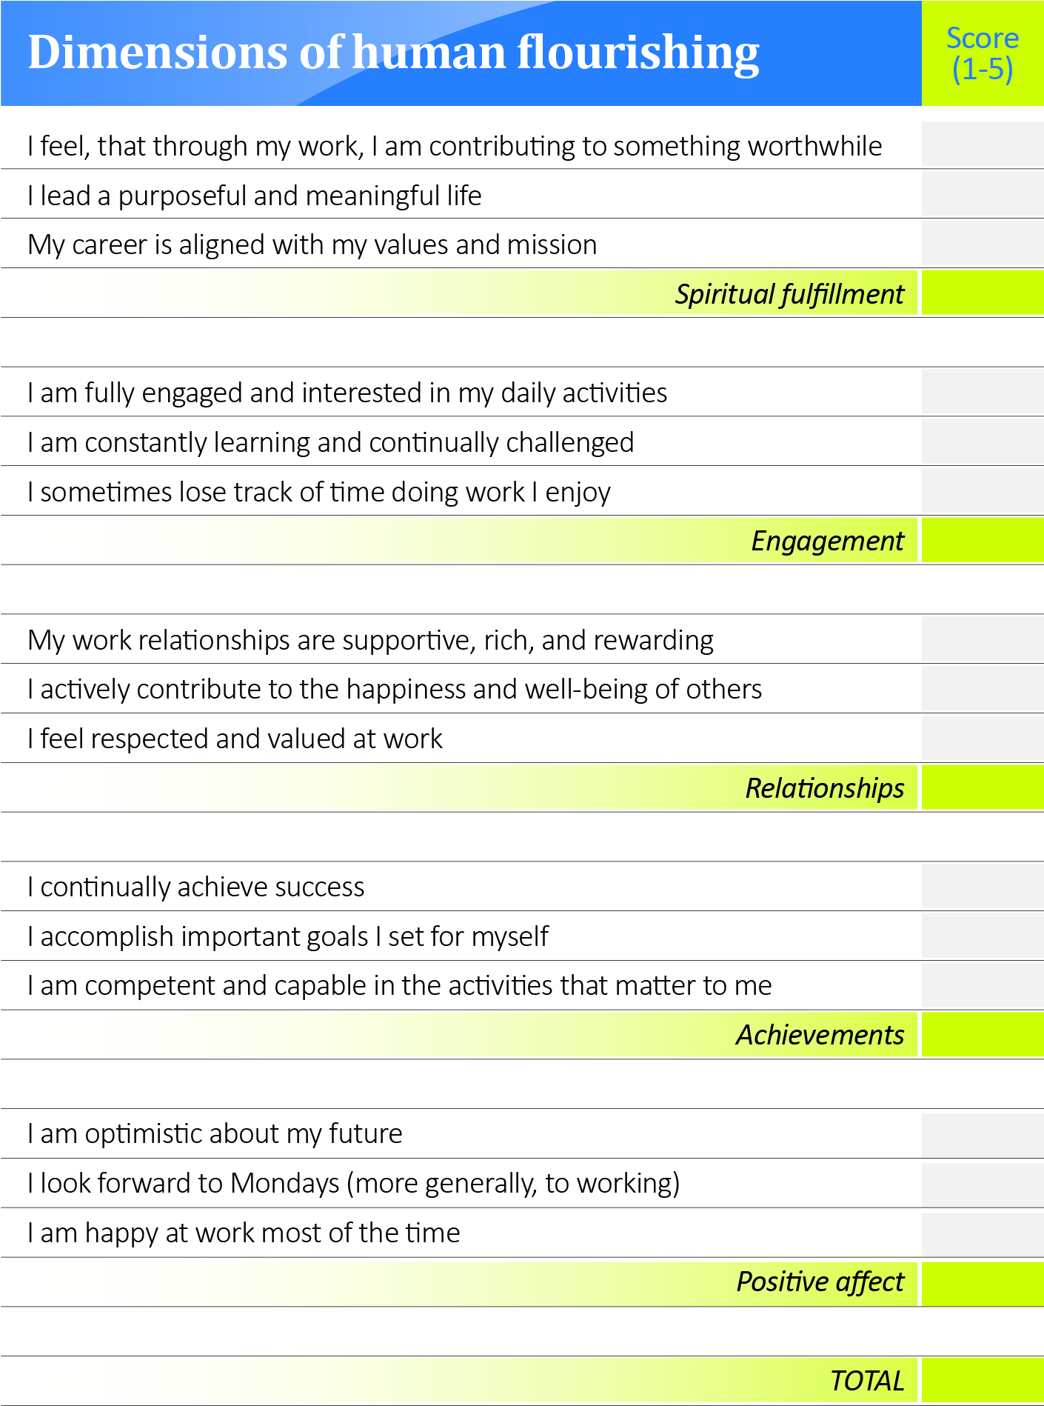
Step 3: Reflecting and journaling
- Which scores are much lower than I would like them to be, and how do I feel about that?

- Is there a particular category I am concerned with (spiritual fulfillment, engagement, relationships, achievement, and/or positive effect), and how do I feel about that?

- For each specific score that concerns you, reflect on the specific circumstances that lead you to score yourself that way. Capture those specifics and reflect on what changes you can make to improve your score.

Step 4: Talking to two or three confidants
Write their names below and email them right now asking for 30 minutes of their time. Explore with them what you are discovering. This will help you clarify and cement it, perhaps validate your thinking, and provide you with the motivation to go on.

SECTION 1, STAGE 2
Step 1: Reflecting and journaling

- If money were not an object, what would I do?

- Whose needs are important as I consider career opportunities?

- What greater causes do I wish to support?

- Where is my skill “sweet spot?”

- In which areas could I be world-class with sufficient effort?

- What are my financial needs?

- Which of my skills are in greatest demand?

SECTION 1, STAGE 3
Step 1: Completing the PAVF Work-Styles Profile

To assess yourself, rank each of the horizontal sets of four words. ‘3’ represents the word that resembles you the most, ‘0’ represents the word that resembles you the least, and ‘2’ and ‘1’ are in between. Make sure each line contains only one instance of each of number, and do not use the same number twice on the same line.

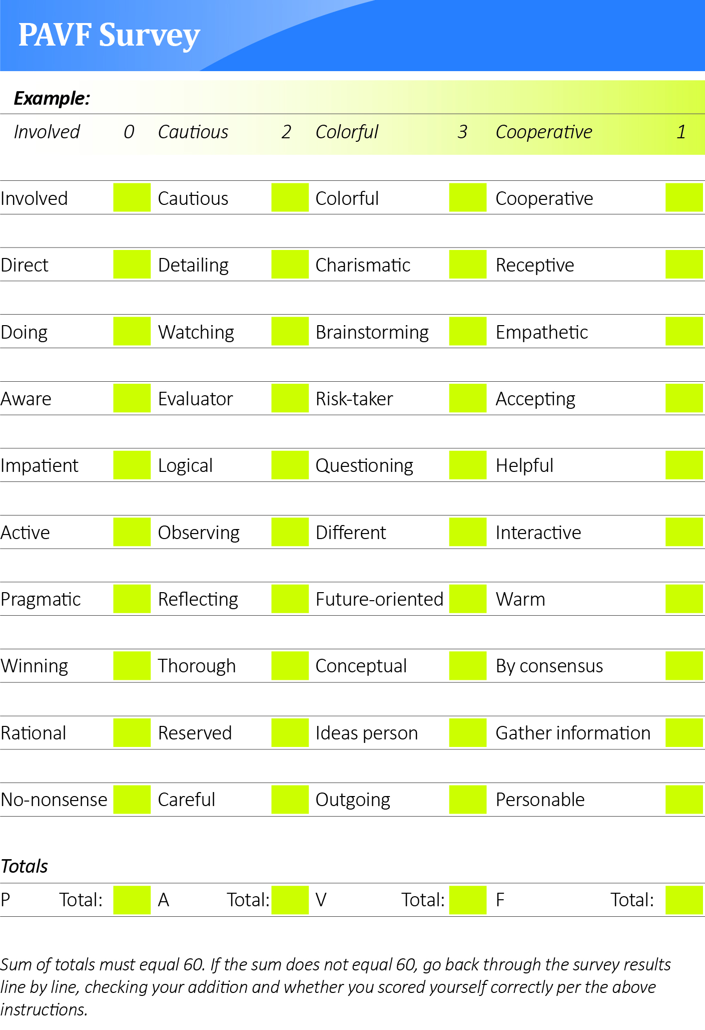
Step 2: Scoring your survey
You should now have four numbers that add up to 60 (for example, P = 12, A = 15, V=20, and F = 13). If the four numbers don’t add up exactly to 60, double-check your score and addition.

Determining dominant and secondary work styles
We define “dominant” (as in, “I am a dominant P”) when your score is 18 or above and “secondary” when your score is 15 or above.

Step 3: Understanding your PAVF profile

Refer back to Week 1 Reading Assignment for a fully detailed explanation of the PAVF approach and interpretation of results.

Step 4: Reflecting and journaling
Ask yourself the following questions:

- Do my score and the associated behaviors and typical careers described make sense to me?

- How has this shifted how I think about myself?

- Is there a link between my “flourishing” and how closely my previous roles match up to this profile?

- Do I feel the need for work more closely aligned with my profile strength(s)?

SECTION 1, STAGE 4
Step 1: Creating a first cut word pile
- First, go back to your PAVF Work-Styles Profiling Survey and circle words that stand out to you from the survey. These are usually words with a score of “3” and are often in your highest-rated columns.

- Next, review the PAVF descriptions (Week 1 Reading Assignment) and below, copy the words you find meaningful from the various descriptor words.

- Now scan through the words in the following table and circle the words you believe best embody who you are and how you operate (both in work and play):

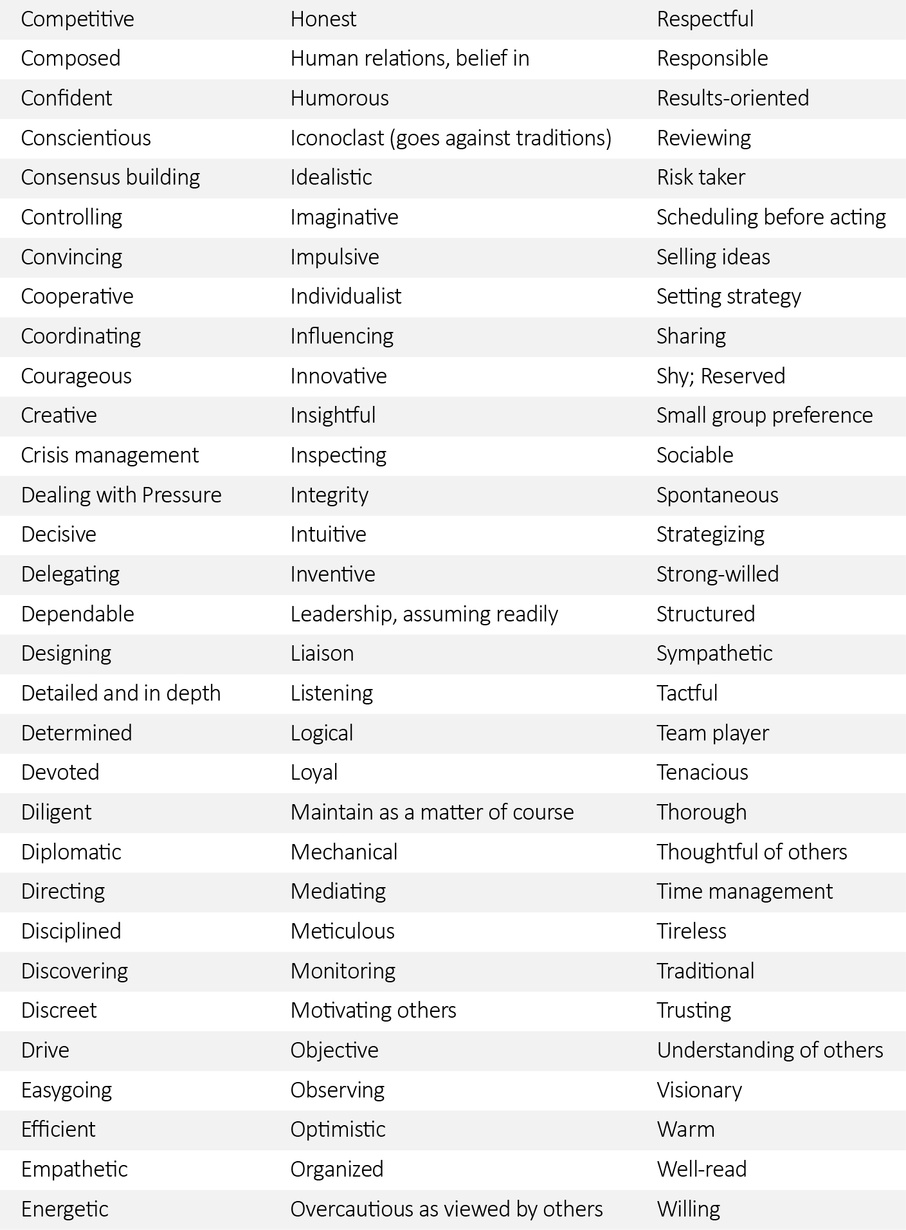

Step 2: Doing the career ad exercise
The purpose of this exercise is twofold: the first is to identify further meaningful words; the second is to expand your horizons toward interesting career opportunities.
- Begin to read want ads from any source: local newspapers, online job boards, out-of-town periodicals, etc.;
- Cut or print out any ads with jobs that appeal to you, regardless of whether or not you are qualified or interested in their geographic location;
- Highlight the words within the ads that appealed to you;
- When you have gathered anywhere from 10 to 20 ads, summarize a list of the words that appealed to you the most and add them to your existing word pile.

Keep a copy of these ads handy with the highlighted words. You will review them again in the next section of this book when you develop your Opportunity Sought statement. There you will have a chance to reflect on the jobs that appeal to you and why they appeal to you, irrespective of whether or not you are qualified for them.

Step 3: Consolidating your first cut list of Descriptors
By now, you probably have 30 to 50 words in your word pile. Take some time now to clean up the list a little more and remove more duplicates and weaker words. Write the cleaned up list on the next page. Try to keep the list to 30 words or less or else it can become cumbersome to work easily with.

FIRST CUT OF DESCRIPTORS (WORD PILE)

SECTION 1, STAGE 5
Step 1: Listing your work and life accomplishments

Write a list of about 12 personal and professional accomplishments, even the nontraditional ones. The work-related ones are usually straightforward; however, sometimes the personal and nontraditional ones provide an insight into your character.

1.

2.

3.

4.

5.

6.

7.

8.

9.

10.

11.

12.

Step 2: Correlating your descriptors with your accomplishments
You now have two different lists: one contains a short description of up to 12 top accomplishments; the other is your pile of words.

Now go through each of your accomplishments, look at your list of words, and circle the ones that you believe were critical components of your success.

To prepare for this activity, start by neatly writing out your words on a single sheet of paper (page 12 has such a list!) and then make up to 12 copies of that page (one copy for each accomplishment). Now:

- Number each of your accomplishments from #1 to #12;
- Grab your first copy of your word sheet, mark it in the corner as #1, and then reading and rereading accomplishment #1, go through your word list and ask yourself: “To accomplish this, was it critical that I was ____________?” If the answer is yes, then circle that word. Repeat for each word on your page. After a few minutes of this, you should have about 8 to 10 words circled on your word page #1.
- Now, grab another word sheet, mark it as #2, and go through accomplishment #2 and ask yourself the same question for every word.
- Complete this exercise for each of your accomplishments. This exercise will probably take you an hour minimum, and possibly up to 90 minutes.

At the end of this exercise, you will have a deeper understanding of the characteristics that contributed to your accomplishments. You are beginning to encapsulate your life in a few words.

Step 3: Reducing your word pile
Now go back through your 12 word sheets and add up which words you used the most. On a clean sheet (next page), under the title Key Descriptors, write down the words you circled most frequently, starting with the most circled word through the list. Record the top seven to nine words circled.

- Look through your new list and old list. Are there any words that didn’t make the short list, but you feel strongly about them and aren’t ready to discard yet?
- Make another list of four to five additional words you feel strongly about but didn’t make the first Key Descriptors cut.
- Keep them separate, but write them out to reflect on later.

In this section, we are selecting words to use in all our communications about our career. Although seemingly simple, it is worth taking your time and reflecting as you are doing it.

KEY DESCRIPTORS (less than 10)

Step 4: Getting feedback from trusted sources
The fastest, most direct way to test and refine your Key Descriptors is to reengage your trusted friends and confidants from previous exercises. Sitting down with your confidants (individually or as a group), ask them to help you validate your list(s). At this point, you will have up to 14 words (if you made a second list of runner-up words) and you want your friends to help you whittle that down to 8 or 9 words. Hopefully your friends will ask you to elaborate, which will deepen the quality of your insights.

During these sessions, take detailed notes. These conversations will provide all kinds of raw input for you to reflect upon and build on in subsequent exercises.

SECTION 1, STAGE 6
Step 1: Creating a mission statement
You may already be living your mission, perhaps without ever having expressed it succinctly. View this exercise as a compelling way of expressing who you already are. To begin creating your mission statement, reflect on the following questions and jot down the answers:

- What do I intend to do about opportunities before me?

- Where will those opportunities take me?

- What careers inspired me when I was young? (Maybe I can’t be an astronaut anymore, but what about being an astronaut was exciting or inspiring?)

- How do I want to serve others?

- What capabilities do I love using?

- What makes me unique?

Step 2: Constructing your vision
- Jot down five to six ideas of what you think your vision statement might be. Don’t over think this or be overly critical about your ideas; write down the first few things that come to mind without judging whether they are believable at this point.

- Set out a timeline on the vertical axis of the next page, starting in one-to two-year increments, and moving along to five-year increments. Then, along the horizontal, place a column for career, for family, for education, and other meaningful pursuits. How will success unfold over those years along the different dimensions of your life (career, family, education, etc.)? What specific milestones along the way will be most important and meaningful?

Time | Career | Family | Education | Other | Other
This year

Next year

Years
3,4

Years
5-7

Years
8+

- Building on these ideas, write down your grand but realistic ambition for yourself. It should reflect what you envision five or ten years down the road. This may be difficult for some; simply do the best you can. Lay out the long-distance view of your life, something clear for you to strive for, within your profession and your life. Remember to include numbers and specificity to help assure reality.

Spend about a week refining your vision. Revise your thoughts as needed, and take notes as you work and rework this exercise. One of Paul’s other books, Reboot Your Life, has several tools, and there are many other free resources online.
Step 3: Declaring your values
- Record your ideas about what your core values are.

From the word list below, circle five to ten words that jump out at you, in both a work and life context;

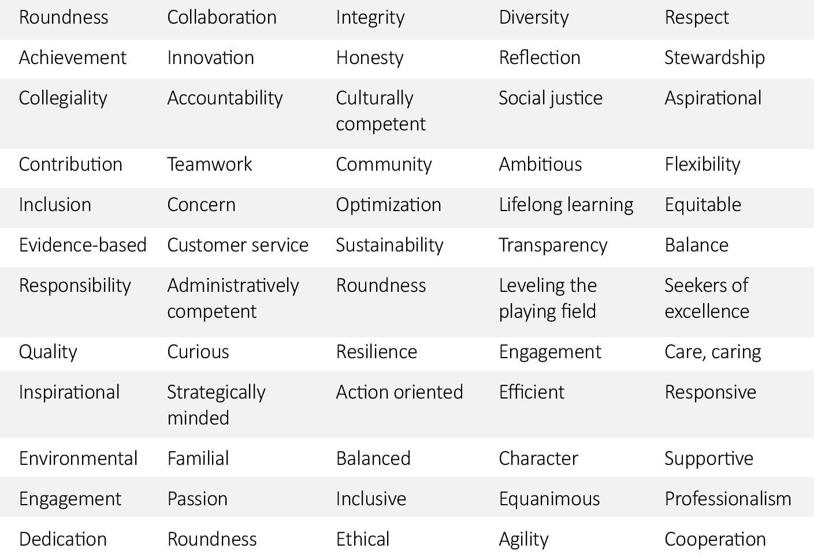

Narrow these down to four to six words that you feel strongly about;

If you think of additional words that are not on the list, jot these down also.

Examining the words you have chosen above, reflect on the following questions:

- What does each word mean to you? Write each word out in a separate sentence that reflects its underlying importance to you.

- For each word, write a short example of how you live that value in your everyday actions.

- Write down a few thoughts about what you hope you would do if you found yourself in a situation where someone was demonstrating the opposite of your chosen value.

Step 4: Sharing this work with your confidants
Once you feel you have a solid working draft of your mission, vision, and values, share them with your confidants. Make sure you capture their feedback.

When you are comfortable with the various components of the mission, vision, and values that make up a personal mission statement, you can combine them into a powerful paragraph that becomes a key aspect of your story (which you will develop more fully in the next section of this book). Here is an example of how the mission, vision, and values work comes together:

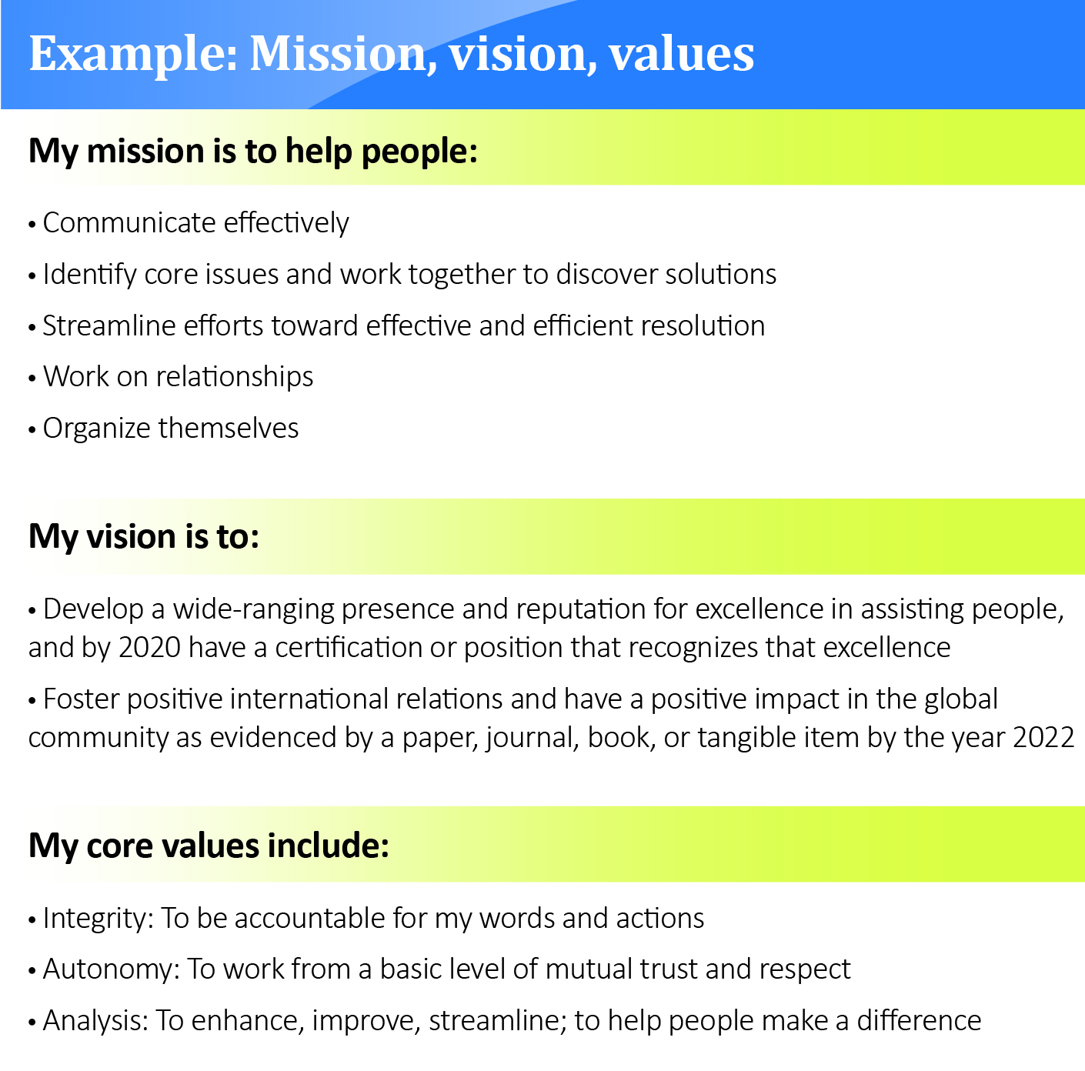

My mission is to:

My vision is to:

My core values include:

Recap
These work assignments has been all about helping you figure out who you are and what truly matters to you—essentially, the “inside job” of deep reflection:
- You captured a baseline of your current flourishing level (an improved expression over happiness, which is often too one-dimensional), and reflected specifically on what you want to improve;
- You completed our PAVF Work-Styles Profiling Survey and developed a clearer sense of your dominant strengths (some combination of Producer, Analyzer, Visionary, and/or Friend);
- From your PAVF profile, you selected powerful words you felt strongly about and can use to describe yourself. You added some “real-world” examples to that list by studying career ads and adding some of their words that you noticed;
- You “unpacked your backpack,” and from that exercise captured up to a dozen of your accomplishments of which you are particularly proud;
- You combined your accomplishments and word pile (we called it “correlating”), and from there reduced your word pile to a much more manageable list that became your Key Descriptors;
- You tested the Key Descriptors with some trusted friends, and took copious notes about their feedback;
- Finally, you reflected on your mission, vision, and values, and pulled them together into a solid first draft of your personal mission statement.

Well done—you’ve set a really strong foundation for the work still to come in the rest of this course.

End of Section One Exercises

